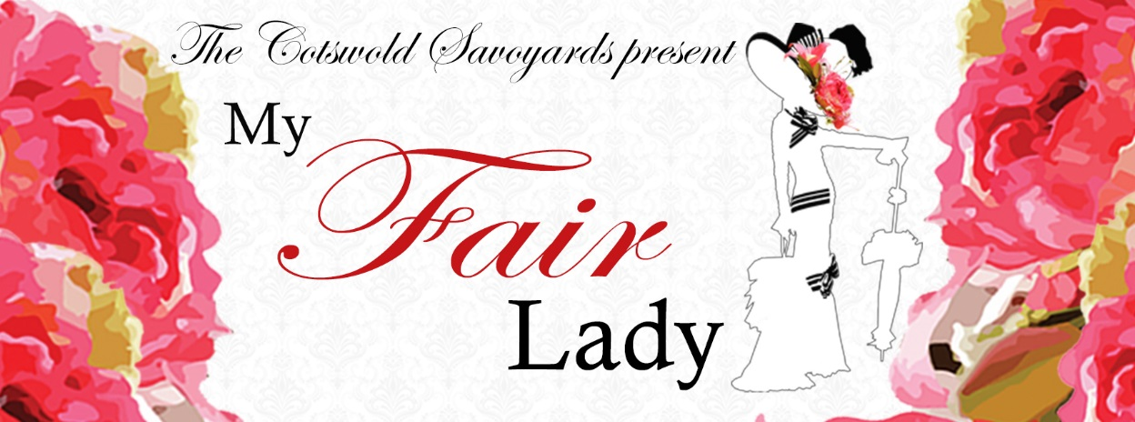

Stage Director: Ginny Burge. Musical Director: Karen Gillespie
Dear Members,

We hope you enjoyed last year’s productions, Pirates of Penzance (Broadway version) at the Everyman Theatre in May as well as A Little Night Music at the Playhouse in November, whether you were on performing, back stage or in the audience. In May 2018, we are delighted to present the blockbuster musical My Fair Lady. We are able to offer you the opportunity of reserving your tickets in advance of general public sales at the Everyman box office, so you can have the best seats. Please have a look at the discount we have available on the booking form for groups of 6+.

You can also buy your tickets electronically. If you wish to take advantage of this method, please email me your requirements (number of seats, dates, preferred seating area, relevant discounts) at ticket.secretary@cotswoldsavoyards.org and arrange to transfer money electronically. The account details for The Cotswold Savoyards are A/C No 25662081, Sort code 09-01-55. For reference when doing this, include “PP- surname”. E.g. PP- Chesworth. I shall transfer your requirements to my records and to keep you from having to send me an SAE, please add an extra 60p to your order which will cover the envelope and stamp.
If replying by post, please indicate an area on the plan overleaf where you would like to sit and I shall allocate the best seats for you (don’t forget to specify stalls/circle etc.) according to my left hand allocation of the auditorium (as you look at the stage). The earliest replies get the best seats as we allocate strictly in the order replies are received. A booking fee of £4 is charged by The Everyman on all ticket sales; this has been included in the prices shown on the booking form. On the booking form, I have shown our half of the Everyman Theatre auditorium with price bands but to see a full colour version of the seating, consult the current Everyman Brochure or visit their website: www.everymantheatre.org.uk/box_office/seating_plan.html.
My Fair Lady is rarely performed by amateur groups and has not been performed in this area for some time so hurry to reserve your seats now. If you would like to book tickets, please complete the enclosed form (where you will find all the necessary details) and return with payment and S.A.E. by 28th February 2018. Tickets will be sent out to you as soon as they are received from the Everyman Theatre. Please make cheques payable to “The Cotswold Savoyards”.
If you have any queries, please contact me via the details given below (which you may like to keep for your records) I look forward to hearing from you. Paul Chesworth, Ticket Secretary
After George Bernard Shaw wrote his very successful play, Pygmalion, he spent decades refusing the rights to turn to it into a musical. But still, the West End and Hollywood dreamt…’Wouldn’t it be loverly…’. Eventually they got their way and a ‘loverly’ stage production was born and the musical was soon immortalised in an iconic rags to riches film.
When Professor Higgins plucks Eliza from the gutter and teaches her to speak correctly, she is propelled into a world far from her roots of selling flowers in Covent Garden. ‘I did it!’ he cries, when his experiment is over, leaving Eliza to ask ‘what’s to become of me?’ and the audience to question whether Eliza was the only one affected by the bet.
We are delighted to bring you a show full of well known songs. So brace yourself for ‘The Rain in Spain’ and ‘With a Little Bit of Luck’ you’ll enjoy everything from a cockney knees-up to a weekend at Ascot and a refined Embassy Ball. So run, now, from ‘The Street Where You Live’ to bag your tickets fast - at least before Eliza starts shouting to ‘move your bloomin' arse!’ - and hopefully you’ll go home wishing you too could have ‘Danced, danced, danced all night’. Ginny Burge, Stage Director

Paul Chesworth, Ticket Secretary, Cotswold Savoyards,
16 Southern Road, Leckhampton, Cheltenham, GL53 9AW
Received Form No:
01242 352512
ticket.secretary@cotswoldsavoyards.org

THE COTSWOLD SAVOYARDS
MEMBERS’ BOOKING FORM
My Fair Lady
EVERYMAN THEATRE, CHELTENHAM TUESDAY 15th – SATURDAY 19th MAY 2018
Evenings: 7.30 pm Matinee: Saturday 2.00 pm

Name: | Tel. No.:
Address:
 | Postcode:

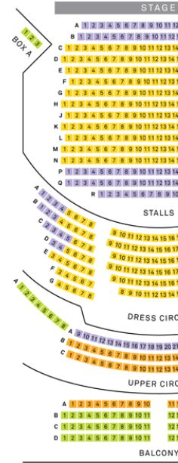
Please indicate number of seats required under each date and price band
(please note any special requests on the seating plan and I will do my best to accommodate them on a first come basis)
Price Band by colour | 1 |  | 2 | 3 | 4 |  | Please leave blank
Tuesday  15th May  Evening | £23 |  | £23 | £21 | £19
Wednesday  16th May  Evening | £23 |  | £23 | £21 | £19
Thursday  17th May  Evening | £23 |  | £23 | £21 | £19
Friday  18th May  Evening | £25 |  | £25 | £23 | £21
Saturday  19th May  Matinee | £25 |  | £25 | £23 | £21
Saturday  19th May  Evening | £25 |  | £25 | £23 | £21
Group of 6+ same performance = £2 discount per ticket
Total Ticket Cost |  | £
Discounts |  | £
Amount Enclosed |  | £
Cheques payable to ‘The Cotswold Savoyards’
We regret that tickets cannot be exchanged or returned after issue
Please return form with full payment and S.A.E. by
28th February 2018 to the address shown at the top of this form.

Note: For some performances seats on the far sides of the dress circle may experience a restricted view.
For a colour chart please visit: www.everymantheatre.org.uk/box_office/seating_plan.html

